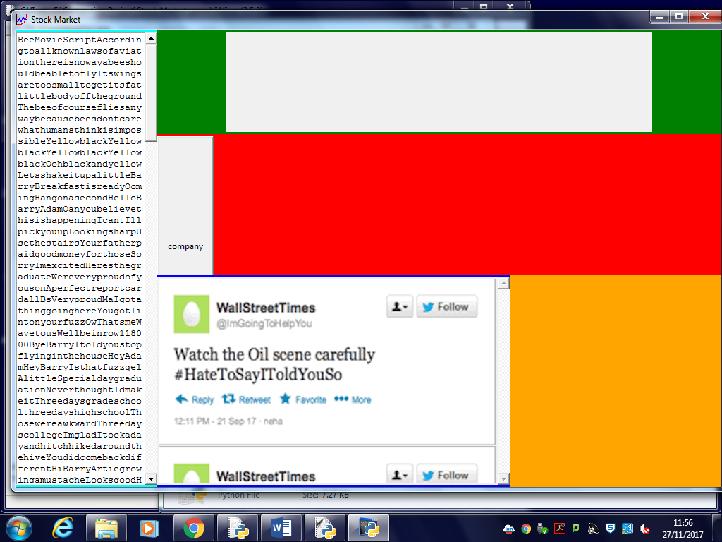

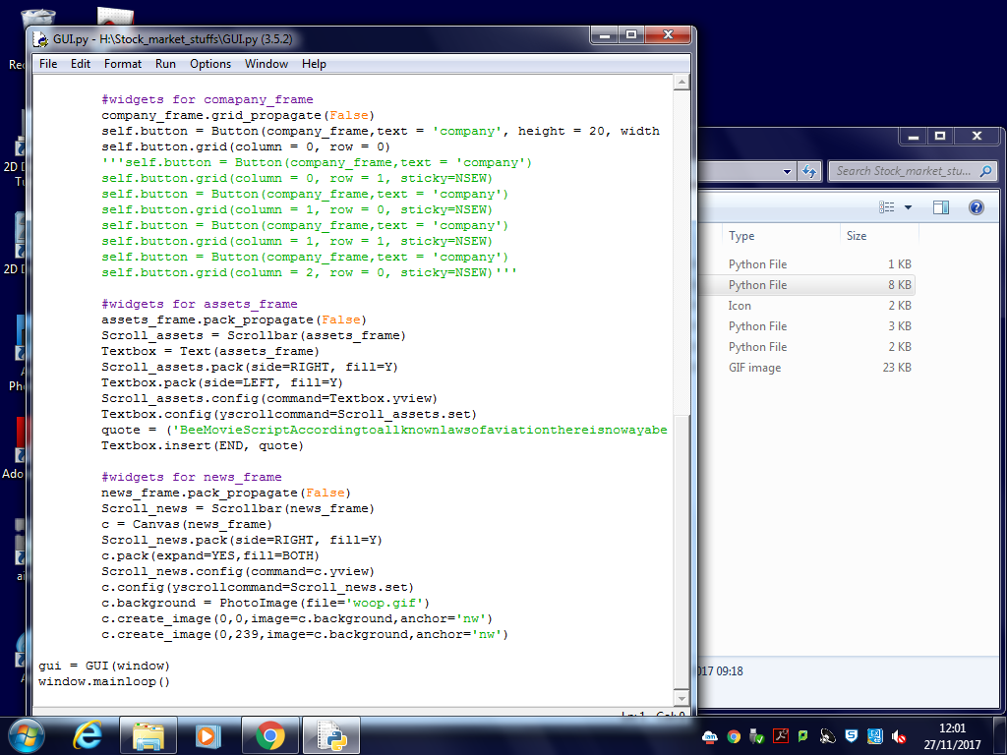

Iteration 1 changes to the design

Trying to get the tweets so scroll so you can look a previous tweets

Cant add a scroll bar to the frame because yview is not an attribute of a frame so cant be added to the news_frame

Then tried to add a bar to a canvas this didn’t work as when images are added to a cavas they aren’t considered as objects so the scroll bar didn’t work as it thinks there is no objects in the cavas as show above (as shown in the two images)

Adding each image as a canvas within a canvas also didn’t work

Therefore decided to have left and right arrows so that the user can do through the images by clicking the next arrows, how every I decided this element can be a favourable feature for now so for the first iteration I plan to only show the user their most recent hint.

Using a main rpgream class a database class and a gui class is similar to a software development method know as model view controller